**Cameron Gayford  
[camgayford@gmail.com]**

CIS219.01 - Introduction to Java

Spring 2014

Program # **4 File I/O, Modified Average**

Date turned in: Thursday May 1, 2014

Due Date: Thursday May 1, 2014  
Completed for Professor Habermas, office D273

Read and parse temperature data from disc,  
process to remove extreme values, and return a modified average.

Sample Output – Console:

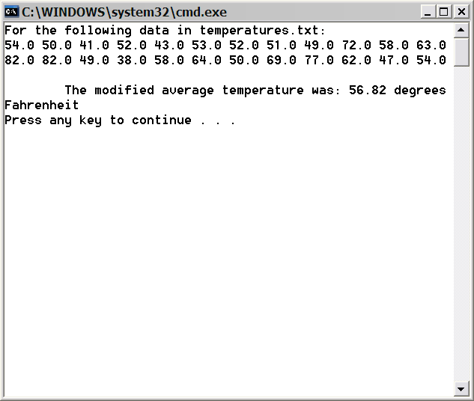

Data Source:

